## How to use the certificate program from Milesight

**Preparation:**

1. **Device**
2. **USB cable**
3. **Milesight Certificate Program Software**

### STEP1

Download the ZIP file: Certification Tool

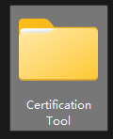

Open the file and find the .exe program: certificationTools.exe

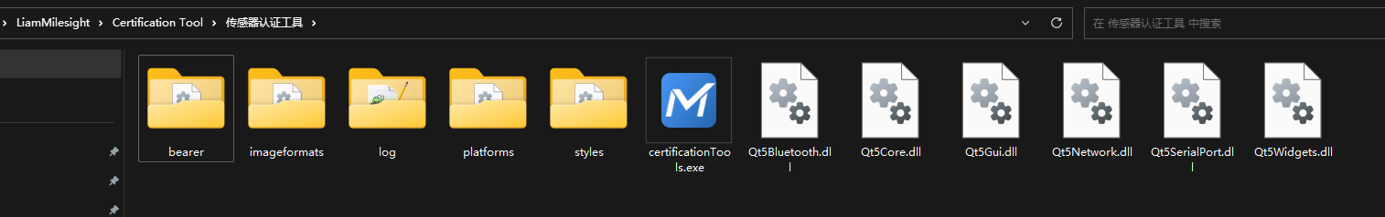

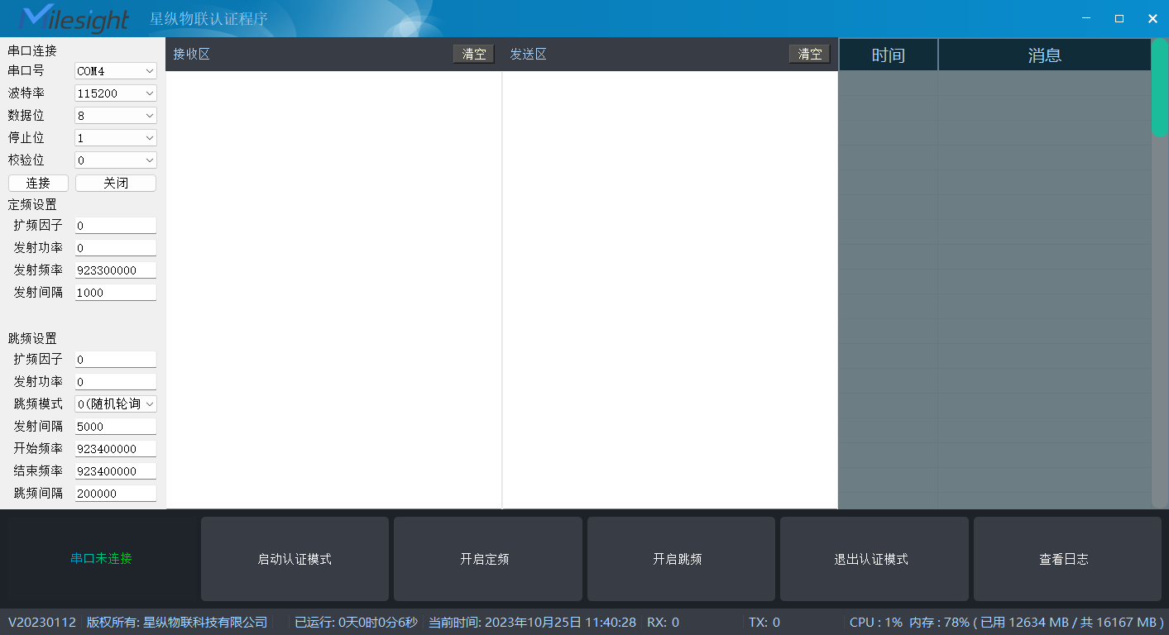

### STEP2

Connect the device’s USB port with your computer via a USB cable

In the Windows Page, press **Ctrl+R** in the keyboard to call up the execute page, and input: devmgmt.msc

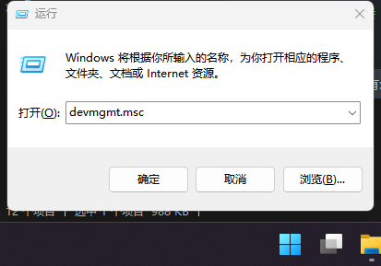

You will find out a **Port** in the **Device Management,** when the USB cable is connected, there’s a corresponding COMx which stands for the serial port.

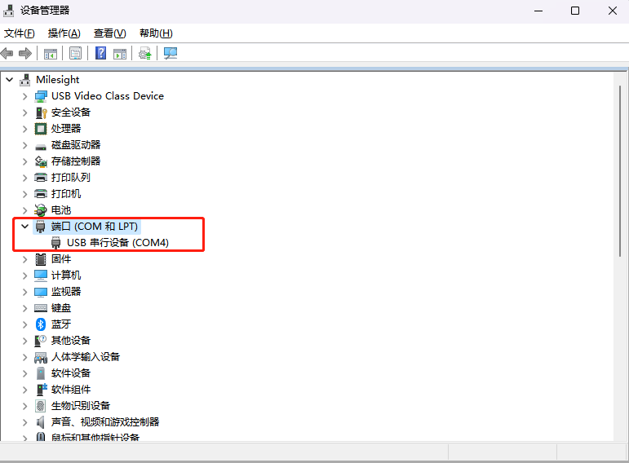

### STEP3

Open the CertificateTools. The left area is recorded the parameters you’re gonna to choose.

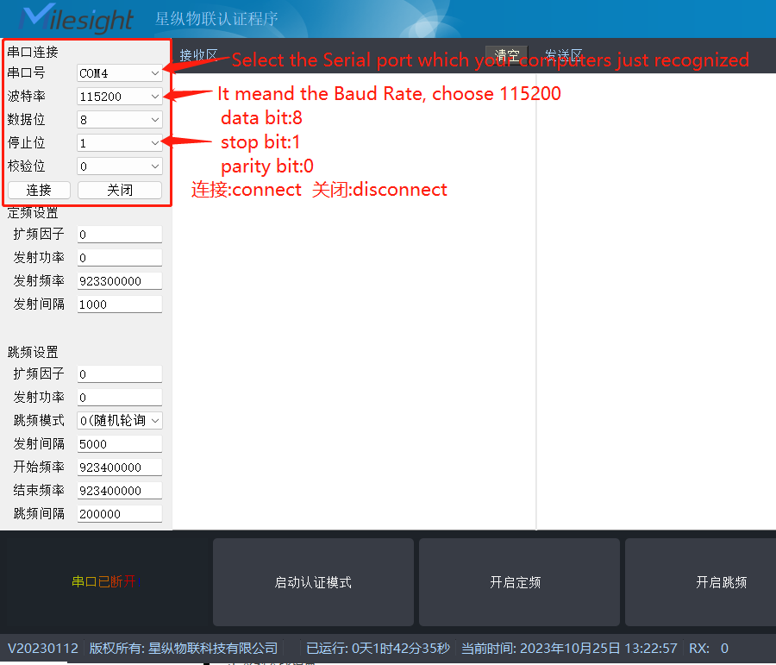

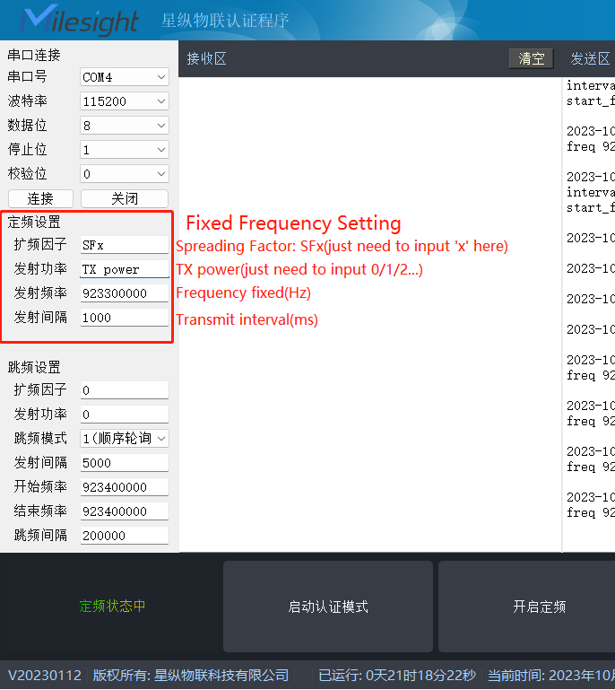

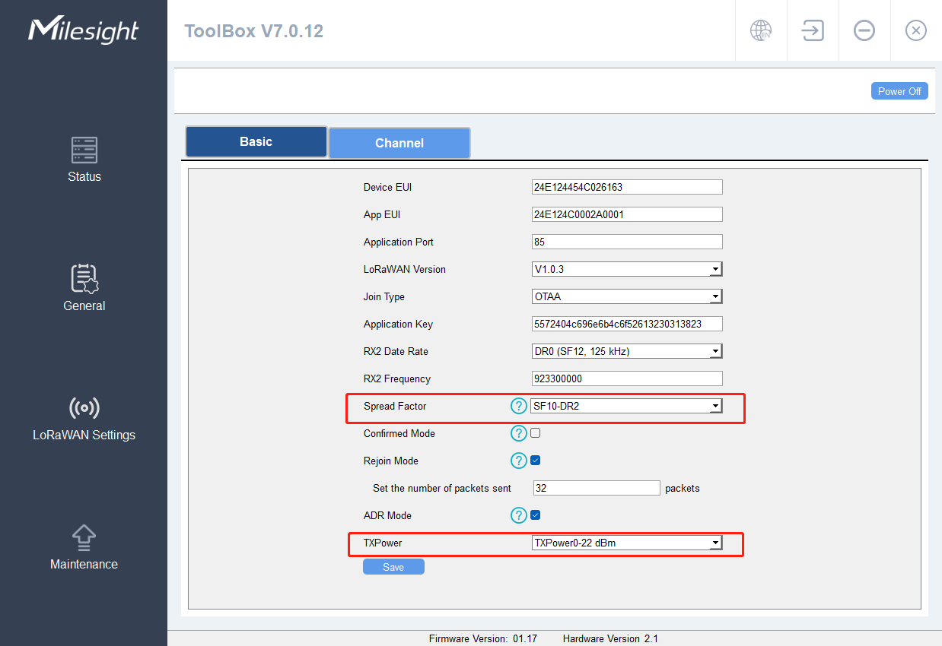

You can download toolbox in your PC and check the Spreading Factor and the TXpower

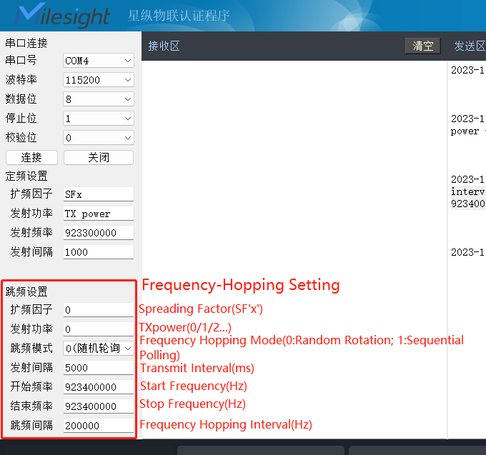

Here are the translation:

串口连接: serial port connection

串口号:COMx

波特率: Baud Rate 115200

数据位: Data Bit 8

停止位: Stop Bit 1

校验位: Parity Bit 0

连接 关闭 Connect Disconnect

定频设置: Fixed Frequency Setting

扩频因子: Spreading Factor, put 0 means DR0.

发射功率: TXpower

发射频率: Transmit Frequency/Fixed

发射间隔: Transmit interval

跳频设置: Frequency Hopping Settings

扩频因子: Spread Factor

发射功率: TXpower

跳频模式: Frequency Hopping Mode

发射间隔: Transmit interval(ms)

开始频率: Start Frequency

结束频率: Stop Frequency

跳频间隔: Frequency Hopping Interval(Hz)

### STEP4

After finishing the parameter settings, we can start the certificate mode and fixed frequency.

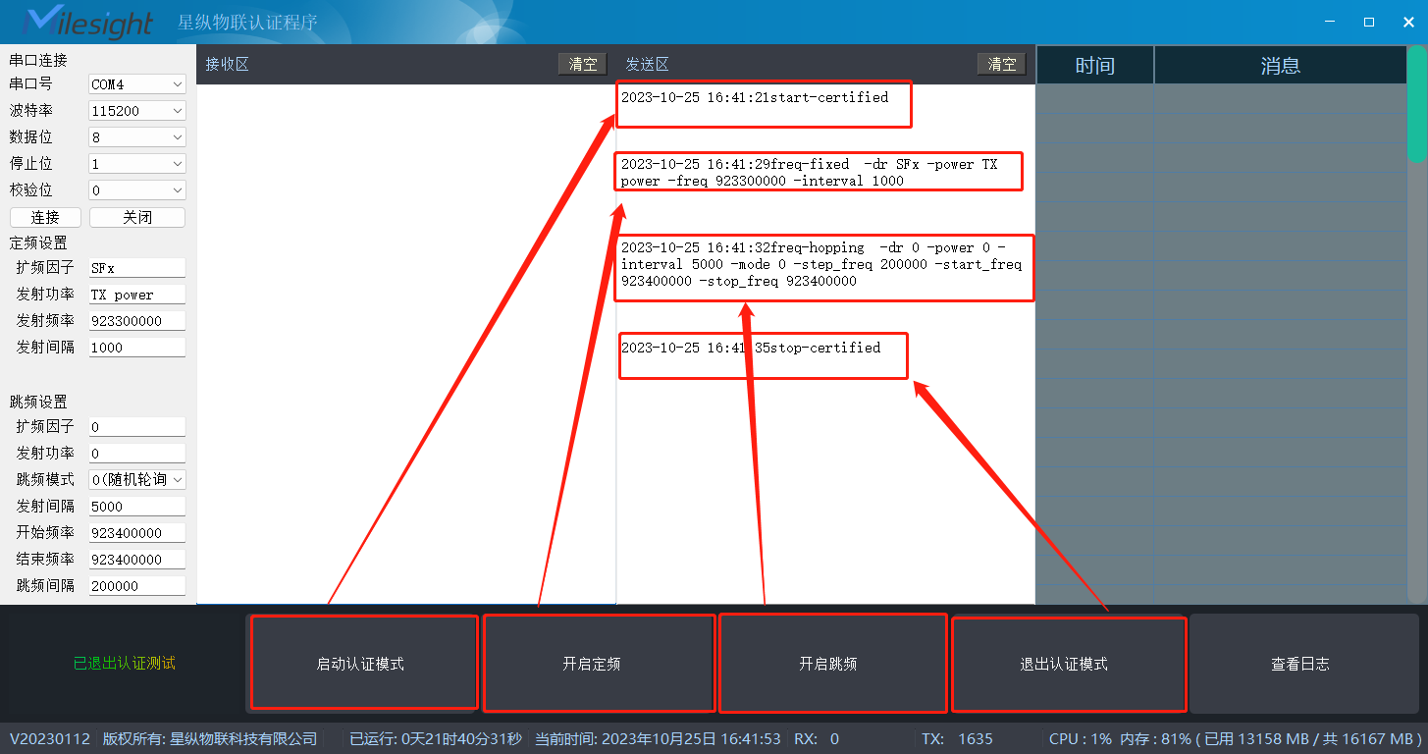

启动认证模式: Start-certified

开启定频: freq-fixed -dr **SFx** -power **TX power** -freq **923300000** -interval **1000**

You can see the left settings will show in the freq-fixed page

开启跳频: freq-hopping -dr **0** -power **0** -interval **5000** -mode **0** -step_freq **200000** -start_freq **923400000** -stop_freq **923400000**

退出认证模式: stop-certificated

### STEP5

Especially, you can check the log via clicking “查看日志”

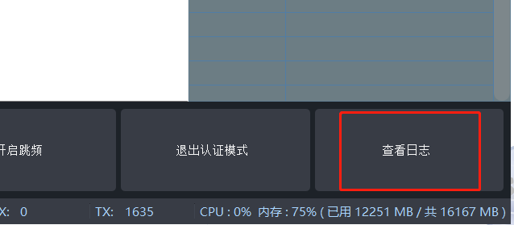

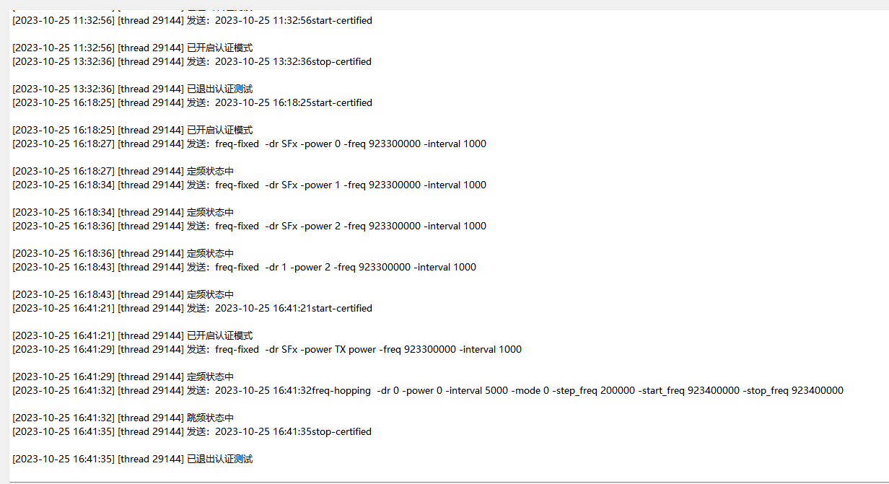

## -END-